**PROJECT – DATABASES**

**COORDINATING PROFESSOR:**

**ANDA BELCIU (VELICANU)**

**STUDENT:**

**BOJAN VLAD-CRISTIAN**

***SECOND-HAND RETAIL STORE FOR LAPTOPS***

This beginner-level project represents a dive into the world of database development, crafting a simple Second-Hand Laptop Retail Database and performing fundamental SQL operations on it. While it may not emulate professional systems, it showcases my initial exploration of the topic.

The idea of the website whose database I have created is based on customers being able to either buy a laptop from our offer or sell us a personal device they don’t want anymore.

On the next page you will see the database schema generated using Oracle SQL Developer’s Data Modeler:

***DATABASE SCHEMA***

**DROP, CREATE, ALTER**



















**INSERT, SEQUENCE, INDEX**





















**UPDATE**

Change a customer’s name:



Result:

Change a review’s message:



Result:

**DELETE**

Insert and delete an address:



**MERGE**

Create table with new prices for laptops and merge it with the laptops table:



Result:

**SELECT STATEMENTS CONTAINING ALL THE NECESSARY ELEMENTS**

1.Select all laptops which are not already sold:



Result:

2.Select all laptops which have the condition of ‘Very Good’:



Result:

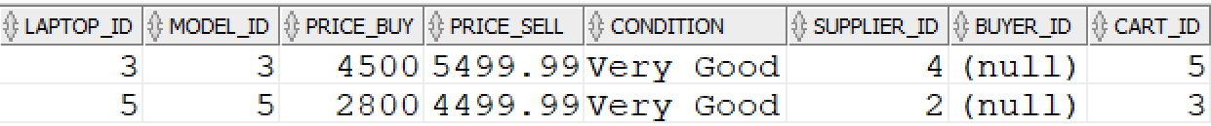

3.Select all laptops which have a condition above ‘Very Good’:



Result:

4.Select all laptops which have a price between 5000 and 6000:



Result:



5.Select all laptops which have a price lower than 4000 and greater than 10000:



Result:



6.Select all laptops which have the sell price higher than all buy prices:



Result:



7.Select all laptops which have the buy price larger than at least one of the sell prices:



Result:

8.Select all customers and all the laptop models they either bought or sold:



Result:

9.Select all carts and the laptops inside:



Result:

10.Select carts which have a total value larger than 3000:



Result:

11.Select all laptops and categorize them based on ssd size:



Result:

12.Select all orders made in June:



Result:

13.Select all the months in which orders were made:



Result:

14.Print the time between today and the last order:



Result:

15.Categorize laptops based on display size:



Result:

16.Select each laptop and its buyer or -1 if there is no buyer yet:



Result:

17.Select people who have gmail intersected with people who have romanian phone number:



Result:



18.Select union of people from Caracal and people from Craiova:



Result:

19.Select all people who don’t have romanian phone number:



Result:

20.Select laptops which have a price lower than the average of the laptops which have a condition of ‘Excellent’:



Result:

21.Create a table which contains every order and the customers who placed the order:



Result:

22.Create a table with fewer data about a laptop and insert the respective rows into it:



Result:

23.Update prices on keydatalaptops with the buy prices of the laptops because we are bankrupt :P:



Result:

24.Join customers and orders tables and use it as a view by selecting all orders which were placed more recently than 2018 together with their customers:



Result:

Just to be sure: I inserted the row with my name in the customers table when doing all the insertions:

